2k erg approaches

Rower,
I'm thinking up a longer response for you, but for now I offer two world record examples to consider. Let's start with a rower I'm betting you’ve heard about while at Granby. Neither video shows splits (no need to watch both), but you can study his rating, the number of strokes, the intensity on his face, etc. There's a very strong start, a smooth settle, a consistent middle, and a long sprint with gradually increasing rating. This approach is thought to work best for small boat rowers (1x, 2-, etc).
https://www.youtube.com/watch?v=FDO1dMM8HJk (no speaking, just rowing)
https://www.youtube.com/watch?v=HjH3inybxSQ (no speaking, just rowing)
Now another rower, a heavyweight. He was close here, and he has since broken the world record time. You can see he takes a very different approach from the first guy, with consistent strokes the whole time (we get to see his rating and splits every stroke). This consistent approach is thought to work best for big boat rowers (8+).
https://www.youtube.com/watch?v=MyN9E417AIQ (cheering crowd)
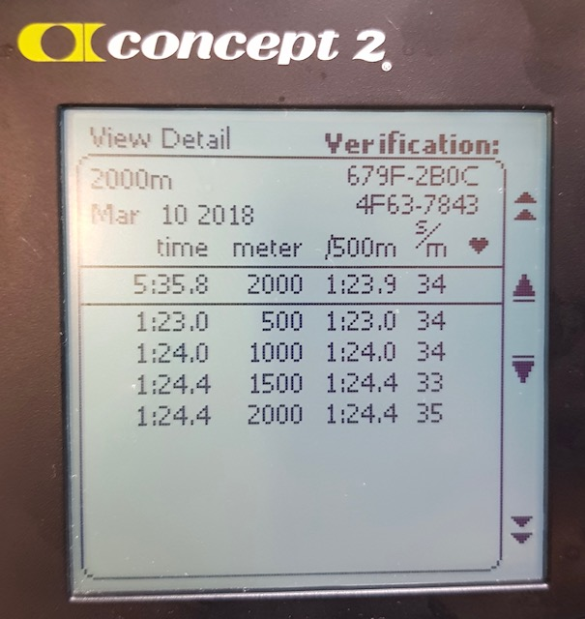
Here is a photo of his splits for the actual world record.
Neither rower's fan setting is easy to pick out, but it looks like a 4 for the LWT, and a 6 for the HWT. My personal approach is a blend of the two. I am not as intense at the start as the LWT, and I back off on the power sooner. But I make sure to do a strong anaerobic start. My middle is constant like the HWT, resisting the times going up. I sprint later than the LWT, but I do sprint. Like the HWT, my rating barely goes up at the end. I wish I could do it more like the LWT, but I don't have the cardio. My base rating is a 30-31.
You should probably shoot to be more like the LWT. His approach is more consistent with how you've trained your body for such athletic efforts.
Ultimately I think each athlete has to pick the approach that works for them. I've chosen mine, but I do experiment from time-to-time to see if I can improve. I think we can be certain the two record holders I'm referencing have also found their best strategy. Yours is out there. Do a bunch of 1500m pieces with totally different approaches. Next year, do it again. Refine the answer. Then tell me what you settled on. I'd appreciate the opportunity to learn from your efforts.
Coach Paul
Email 2

Ok, that email turned out longer than I expected. I guess I can complete the lesson with a bit more. My most important advice remains that you should find the path that best works for you.
The “ideal” template I would offer begins with an aggressive start with power that pushes your instantaneous split to 2k-10 or 2k-15 by the fourth stroke. Rating should be very high, but don’t take it so high that your strokes become uncontrolled and less effective. The adrenaline in your blood and stored glycogen in your muscles should fuel this early effort, so you don't pay much of a cost in lactic acid or aerobic fatigue. Hold the intensity, for a bit, but don't go crazy. At around stroke 8 to 10, start drifting toward your base pace (both split and rating). Don't get there immediately. Let the adrenaline and early power get your average split below the goal pace you want to see at the end. You should not try to keep the numbers low, just realize how easy it is to keep them low, and start willing them to come up. The rating will hit base pace before the split does. If you've got cardio to spare, take longer to get the rating down.
The key is the middle. Every stroke doesn't have to be exactly the same, but they need to be close. Find your split and rating, and hold them. You need to be a machine; manufacture those strokes over and over. From 1700-1200 it's not too difficult; think about fluid motion. Shoot for the exact average split you want at the end. Only use the muscles that are producing power; stay relaxed. Establish a breathing rhythm, and use it with the rating to produce the fastest times with the least effort. Save the gas for the end, you're going to need it. Don't fly and die, but don't sell yourself short. From 1200-700 the perceived effort is going from worrying, to really-not-fun; remember to be the machine. Even though it hurts, you still need to be efficient and consistent. Your instantaneous split will come up above the average target occasionally. That’s fine. Push it back down with calm/controlled adjustments. Watch your average split drift up toward the target, but remember you're still faster than your target final average because of your fast start.
From 700-300, it's about holding on. You're so close to the end, and you're getting closer with every stroke. Breathing can be faster, but do not start gasping or hyperventilate. Your aerobic engine has to produce these strokes; keep it running right. That engine likes a constant RPM, even at the very edge of it's ability, so don't mess with the rating. Realize that pain is the human body's way of saying we should stop now or we might not have enough in reserve for an emergency. The cave-man in you still wants to be able to sprint up a tree to escape a lion; your brain is setting limits that don't make sense... there are no lions nearby. You can't ignore the pain, but you can realize it is not actually dictating the power in your muscles. Machines don't feel pain. Keep manufacturing those good strokes. They won't look nearly as pretty, but you can do it. The instantaneous split will go up a bit, and the average split will go slightly above your target. Keep the instantaneous splits within 5 of target, and keep the average split within 0.5 of target.
At 300, the anaerobic engine can start helping again, and keep helping all the way to the end. Don't go nuts. Assess where you are. 300 to 200 needs to ramp up slowly on rating and power. 200 to 100 needs to keep the rating going up until breathing feels difficult; splits should still be going down, but not by much. If you’re seeing 2k-10 again, then there are three possibilities: you didn't use enough of your aerobic capacity in the middle, you are all power and no cardio, and/or you've got a crazy adrenaline surge for some reason. Train to reach splits of perhaps 2k-5 with 100 left to go. From 100 to the finish, your splits need to be going up again. You need to be getting slower. Don't lose it, but just fail to hold it. You're failing because there's just nothing left in your body and mind; now it's all heart/courage. If you're still getting faster at 70m to go, you waited too late to sprint. These last 12-15 strokes aren't going to affect your time much. Just do whatever you can to get to the line.
The numbers (margins to final average split) will vary with your athletic strengths. If you’re a power athlete, then the start and the sprint will see lower splits while the middle see’s higher splits. If you’re endurance, the instantaneous splits will be close to the average splits. That HWT is powerful, but his consistent splits indicate that he is achieving his speed with endurance and pain tolerance. He’s using the aerobic engine most. What you absolutely do not want to do is bounce up and down, up and down (splits or rating). That will break your aerobic engine and it will call on your anaerobic engine too often. This can happen when you don’t have a good plan. All the splits in this email are based on having a reasonable target average split, and following a plan to get there. You can take a risk and barely miss your target. You can’t go nuts, and then make excuses.
I like the idea of having a focus point for each portion. During the start, I'm excited that I did it again. I started another terrifying 2k, which is something to be proud of. From 1700-1200 I remember my advice to the team about discipline. I become the machine I coach them to be. From 1200 to 700 I focus on my hatred of hypocrisy. I won't be a hypocrite. I tell the students to be brave and push hard, so that's what I'm going to do. From 700 to 300 I look for motivation to fight. I think about defending my family, or pushing back against the slow degradation of my body with age. From 300 to finish there's not much thought. I'm just counting the number of strokes I think I have left and pulling harder until I can't pull any harder... until I can't pull any more. I make it sound worse than it probably is, but when I'm on the erg I try to make it worse than it probably sounds. Great results often come from winning that battle.
Coach Paul
PS - Don't forget how both those record-setting rowers looked at the end of their ergs. You couldn't see life-altering pain on their faces and in their bodies. As a coach and athlete, I've always focused too much on the effort and the pain. Pain does not define success... success defines success. Don't sit down to destroy yourself. Sit down to destroy your previous pace.

Equipment considerations

The LWT’s fan setting was 4-ish, and the HWT’s setting was 6-ish. It is almost always the case that heavier people have higher fan settings. But rating and height must also be accounted for. Take the average human, and select a fan setting as follows (each bullet assumes all other bullets are constant at that of the average human):
- more body weight, raise the fan
- more height (longer strokes), lower the fan
- more flexibility (longer strokes), lower the fan
- preference for low rating, raise the fan (and vice versa)
- emphasis on power, raise the fan

A drill for improving 2k pace

To work on rowing like the HWT (constant splits the whole way yielding a good result) here is a specific drill to try. Take your current 2k split (let's say 1:50). Now sit down on the erg, select "just row" on the screen, and pull at 2k pace minus 10 (1:40). Do a strong start so your average is (no more than 1sec) below 1:40. Then hold 1:40. Use 2k fan and 2k rating (or a tiny big higher). Watch your average split creep up to 1:40 while you hold constant instantaneous splits like the HWT.
At some point you'll no longer be able to hold 1:40. That's fine; that's why this is a drill and not a 2k test. Your goal is to go as far as possible at 2k minus 10. Your goal is to sustain more-than-2k power through the middle, and then sprint to hang on even longer at the end. Add rating or power as the average approaches 1:40. Fight hard and keep the average under the line. Once the average goes over (1:40.1), stop rowing. Maybe do some cool-down strokes, but no more hard pulling. Write down how far you got. Next time, go further.
It's a completely different challenge from a 2k. At the very end you need just one more stroke to stay below, then one more, then one more. You aren't sprinting to the line, because the line is right in front of you, one more stroke away. You have to step over that line. And if you could step once more, can you do it once more?
This workout is not meant to make you stronger. It is meant to expand your perspective on 2k testing. Many people don’t go fast enough at the start because they are afraid of the pain in the middle. Other people don’t go fast enough because they don’t have the imagination necessary to conceive of how strong they really are. In this drill, you get to take a risk without there being any repercussions.
The drill shouldn’t last long. Knowing this should help you bravely attack the drill. If you can go more than 1k at this pace, then your actual 2k pace is faster than you think it is. Just don’t let the expected duration/distance be an excuse to give up early. Doing this drill is meaningless if you don’t fight for every last stroke to stay 2k-10 (average).

