Setting Equipment
Why: Proper equipment setup makes a boat faster. The many adjustments possible with modern rowing equipment can help rowers of very different sizes, flexibilities, strengths, and skills row together. Bad equipment setup slows the boat down in too many ways to describe. But for motivation’s sake, here are a few examples:
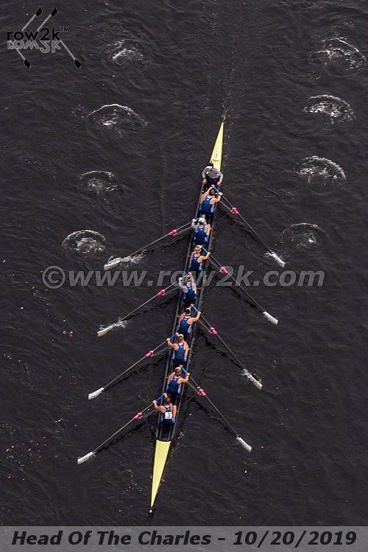
- An oar blade that is too deep in the water will not release cleanly, acting like an anchor at the finish.
- A blade too shallow will slip through the water, wasting the rower’s pull.
- An oar swinging through the wrong arc creates less forward force on the boat.
- The boat is unset by bad pitch, arcs, timing, etc.
- Bad geometry shortens the stroke and/or prevents a smooth rowing motion.
- Bad fit prevents efficient or full power application.
- Varied setup from day-to-day makes consistent practice impossible preventing achievement of precise rowing technique.
- Coaches may mistake flaws in equipment for flaws in the rower, causing them to offer corrections that make the rower worse.
- A warn-out oarlock will make you catch a crab.
- Lose equipment flexes, giving away power.
- Equipment that breaks… well that’s obviously bad.
Priorities and Responsibilities: Equipment is team priority four. It comes after safety, safesport, and teaching/learning. But it comes before everything else we do, including physical fitness and rowing technique. Equipment impacts safety, teaching, learning, fitness, and technique. Proper setup is only one part of the equipment priority, but it is a daily responsibility of rowers, coxswains, and coaches. Every practice or race requires verification that equipment setup is ready.
Scope: Equipment setup is more commonly known as “rigging” in the rowing community. This document does not cover the most complex aspects of rigging. There are entire books on the subject. Nor does it cover the simple things, like making sure the seat is in the tracks correctly. The coaches will worry about the complex stuff. The athletes must get the simple stuff right.
Equipment quality affects boat speed and rowing technique, but that is not covered here. Our team works with what we’ve got. That said, athletes need to point out problems so they might be fixed.
Technique Categories: Equipment setup does not fit in any of the team’s five technique categories. In fact, technique corrections assume perfect equipment setup. Conversely, changes to equipment setup assume perfect technique. A rower washing-out at the finish because of excessive lay-back does not need to adjust their equipment to fix oar depth.
When: Set your equipment. Adjust it today. Fix it between stretches of rowing as needed. If there’s something wrong, take the next opportunity make it right. If you have a question, ask it now.
- Start on land. Unless you are the only one who rows in a specific seat with bespoke oars, then it’s likely you’ll need to move something. It’s possible you’ll need to move everything. Water time is a limited and precious resource in building boat speed. Don’t waste it by leaving adjustments to be made on the water. Many equipment adjustments are much easier on land.
- On the water, verify everything again. Coarse adjustments are made on land. Make fine adjustments when the actual geometry can be seen and strokes can be taken.
  - Check as an individual. Many ajustments are done to fit the rower to the shell.
  - Check at the first opportunity after leaving the dock. When the boat is stopped, do your checks.
  - Check as a crew. Several adjustments are done to fit the crew to the shell. All that remain are done to fit the individual rower to the rest of the rowers in the boat.
  - Check while rowing. A rower’s static finish position is never exactly the same as their actual rowing finish. It’s not enough to think everything fits. Prove it with good strokes.
- On race day, athletes need to be calm and confident. There’s plenty to worry about in racing. All the
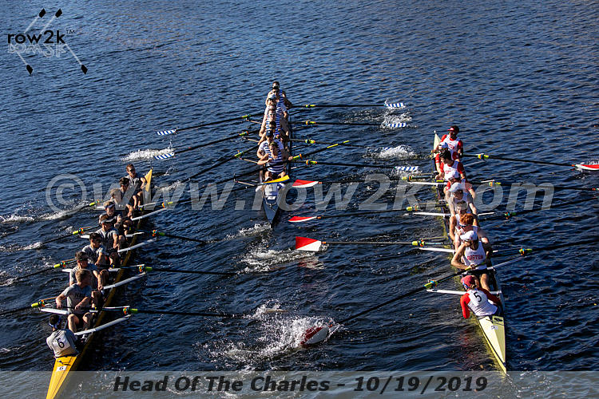
worrying about equipmentneeds to done. That said, there are slight adjustments that can be made for the conditions.
  - Strong headwinds might call for adding a clam; strong tailwinds, removing a clam.
  - Heaving chop might call for raising blade heights.
- Over time, look for changes. If you get taller, more flexible, or stronger, your setup is going to change.
What and Where: The equipment that can be adjusted depends on the boat/oar. Age and/or manufacturer affect the list. Some changes are easy to make, some are difficult. A few changes take far too much work to be done for a single practice and/or race. No matter the ease, this entire list should be considered. Athletes must ask coaches about adjustment they are not sure of before making the adjustment. Along with each thing to be changed, the proper location to check its status is provided.
- Shoe size: shoes that are too small limit power application through the heels. Shoes that are too big limit the rower’s ability to firmly/smoothly transition from the drive to the recovery. This should be checked with shoes out of the boat, or by approximating with hand-size comparisons.
- Seat height (butt pads): rowers with short torsos will need to raise their shoulders high enough to keep their blades properly submerged through the stroke. Check this at the finish. With no pop-outs under the oarlock, the blade should be deep enough to have the water touching the bottom of the oar shaft where it meets the blade. Changing just the seat moves the chest up/down at the catch in relation to the knees. An accompanying change in shoe depth may be needed.
- Shoe depth: rowers with long shins will need to lower their feet so their knees do not get in the way at the catch. This adjustment is specifically about heel depth. For example, a rower that fits size 8 shoes who usually needs to lower their feet may not need to do so when rowing in size 10 shoes.
  - Check first at the catch. The top of the knees should be below the arm-pits, but above the bottom of the sternum. Where specifically depends on the rower’s toros length versus thigh length.
  - Check next at the finish. Feet that are too deep in the boat may cause calfs to hit the deck, limiting the ability to drive the knees down. If the knee/chest height relations at the catch was correct, seat height and shoe depth may both need to come up in equal amouts. That, or the feet may need to be moved to the stern. But this second solution has implications described below.
  - Changing heel depth (shoe depth or size) up/down also moves the heels to the stern/bow. An accompanying change in foot-stretcher position bow-to-stern may be needed.
- Foot-stretchers bow-to-stern: about 2/3 of the oar’s arc around the pin should be on the stern side
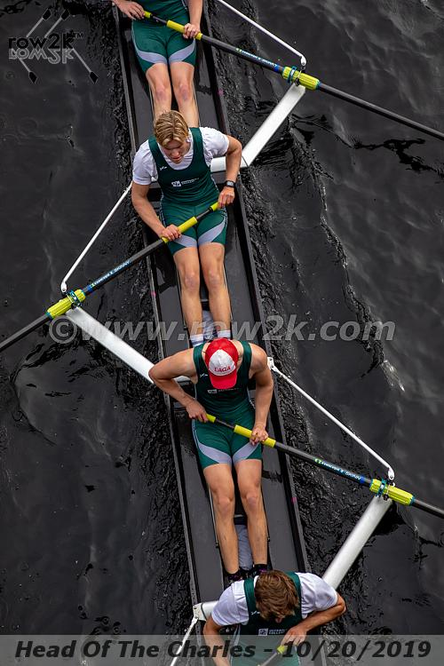
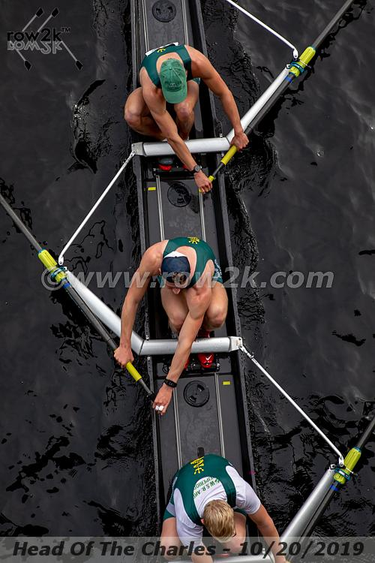
of perpendicular to the boat’s keel, leaving 1/3 of the arc to the bow. Compare the pictured angles and positions of the outside hand at the catch and at the finish. In general, rowers with longer legs will have their feet more to the stern.
  - Check first at the finish. In sculling, the thumbs brush up against the bottom of the curve in the front side of the lowest ribs. For sweep, the handle rotates inward until the butt of the outside hand at the base of the thumb brush the same spot. Don’t worry about blade depth in making this check. That problem is fixed on the pin.
  - Check next at the catch. Compare the angle to the stern-stay (of a euro-rigger) / mainstay (of a wing rigger). All wing riggers in a boat are the same angle versus the keel of that boat. Euro-riggers are close to the same angle, all . These angles vary boat-to-boat, so the hands-to-stay relationship is not always the same. Finish angles take priority.
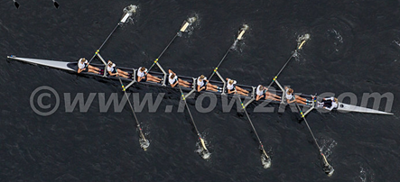
  - Check the entire crew. The oars should be parallel, swinging through the same arc. Match up the finish angles when the boat is steady. Verify they match while rowing too.
  - Moving the feet/ foot-stretcher far enough to the stern or bow may require the slide positions to be adjustmented.
  - Adjusting the feet affects the layback necessary for proper handle-to-rib cage alignment. Changing layback afffects hand heights. An accompanying change in popouts may be needed.
- Slides position: hitting the stern-stops at the catch or bow-stops at the finish requires slides to move. At minimum, the slides must be even or this can result in seats hoping out of the tracks.
- Popouts: rowers with tall torosos will need to raise their oarlocks high enough to keep their blades from being too deep to properly release. There should be enough popouts on the pin to achieve this. If not, spacers above the oarlock should move below. After that, more complex changes are needed.
  - Check this at the finish. The water touches the bottom of the oar shaft where it meets the blade.
  - Blade height/depth through the rest of the recovery/drive is usually not an equipment problem.
- CLAMs (Collar Length Adjustment Mechanism): matched timing during the drive requires that every oar blade move (in relation to the shell) with the same outboard length. When all oars are the same, this means every rower must move through the same inboard length. This is not always achievable. Rowers that have less inboard length due to height and/or flexibility will need to remove clams from the outboard side of the collar. Rowers with more inboard length will need to a add outboard clams. Check this during full strokes. Rowers must lock on and then release from the water in unison.
How: In setting equipment everything affects everything else. Change the oar angle, and timing will differ. Adjust oar loading with clams, and blade depth will differ. Here is:
- Remember what you usually do. Rowers who normally takes two clams off should probably do it for this row. If you’ve rowed in this shell before, you should know (approximately) where to move all your equipment. Shells are not made perfectly, so this could vary slightly seat-to-seat.
- Assess the crew around you. If everyone usually adds a clam on the outboard side of the collar, maybe you can all leave the extra clams off.
- Adjust oars for the boat. A four/pair generally needs one more outboard clam than an eight/quad.
- Remember that equipment cannot be set perfectly until technique is perfect, and vice versa. Both must be refined together. When checking equipment, take the best possible strokes you can.
  - Bad technique will hide necessary changes, while tricking crews into making unnecssary changes. This is true while rowing and while sitting still at any position in the rowing stroke.
  - Rowers must demand intense focus from themsleves. Control your body and your blade precisely.
  - Coxswains and coaches must demand perfect rowing, and call out big technique problems fast.
- When the boats is stopped, the entire crew comes to the finish to check oar angles and blade depths and/or seat height. The coxswain stands to verfy they agree with layback positions and parallel oars.
- The coxswain sits or crouches, then the rower sit at the catch to check comfort. The coxswain stands to verfy they agree with bodies turning around the inside knee, and that oars will remain parallel. If parallel is lost, this likely means clams will have to change after continuos rowing checks.
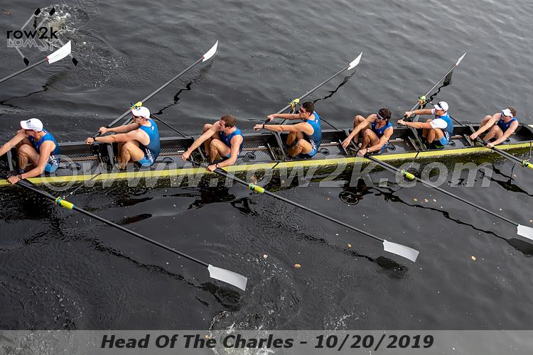
- Row at full strokes. No other rowing (e.g. arms-and-body) will verify all aspects of equipment are set.
  - Consider having rowers sit out to set the boat. Bad set effects oar depth, handle height, etc. These effects hide necessary changes, while tricking crews into making unnecssary changes.
  - Row on the square. Don’t let bad feathering ruin assessment of timing and oar angles.
  - Row with the feather. Exact blade movement around the finish can only be done while feathering.
  - Rowers, feel where the handle(s) is hitting your body at the finish. Verify you can release cleanly.
  - Coxswains, concentrate on timing. With that fixed, look for parallel oars, then blades washing out.
  - Coaches will drive around the boat looking at oar angles, and rower body control.
- Don’t stop the boat eight times to fix each rower separately. Catalog changes to be made, and by approximately how much. Coxswains/coaches, tell the rowers exactly what is needed so they can remember the list. Build the catalog quickly and then stop to make changes.
  - Change the clams first. Timing is most important, and this can be done fast. Get rowing again.
  - Then move the foot stretchers. This is the part that can move the most (forward/back, up/down). These changes offer the most variability for the rower, and that other equipment will adapt to.
  - Popouts can be done at the same time as the as feet, but must be done with the boat stopped.
  - If everything should be perfect and there is time, row a bit more to check.
- Don’t undo changes with stationary verifications that were made while rowing, unless technique also changes in a way that justifies the adjustment. The poing of all this effort is to set perfect rowing equipment, not perfect “sit there and look pretty” equipment.
- Don’t waste time. After all this fiddling gets done, we’ve still got trianing to complete.
Feel/speed: The rigging might look perfect. That doesn’t mean it is perfect. If you don’t fit right or you can’t properly apply your power, say so. If the entire crew agrees the oars feel too heavy or the desired rating cannot be achieved, all rowers add outboard clams. If weight is too light or the rating is too high, add clams. On the other hand, maximum speed does not necessarily feel great. Ultimately this is about making the boat faster. If the means to test speed is available, that should always be done.
Don’t fix: There are some rigging details that athletes should not check or change. However, it is worth knowing these adjustments exist, and can be requested if really needed.
- Oarlock pitch: there is a standard pitch that allows most blades to work best. But pitch may change to account for problems in setting the boat, washing out, catching crabs, and more.
- Spacers: these are like popouts, but cannot be removed from the pin without tools. There should be enough so the handle height is high enough to prevent rowers bashing their hands into anything.
- Oar loading: this is about weight of the oar (discussed above), but includes much more than clams. This matters if the oar does not have clams, or more adjustments are needed beyond clams.
  - Special oar lengths can be set up for rowers who are too short to stay with their boat’s length.
  - A special oar may require a different oar angle at the finish and/or a special pin spread.
- Pin spread: this is adjusted to move the oar left or right in front of the rower, but affects much more.
- Foot-stretcher angle: this affects ability to press the heels down all the way through the drive?
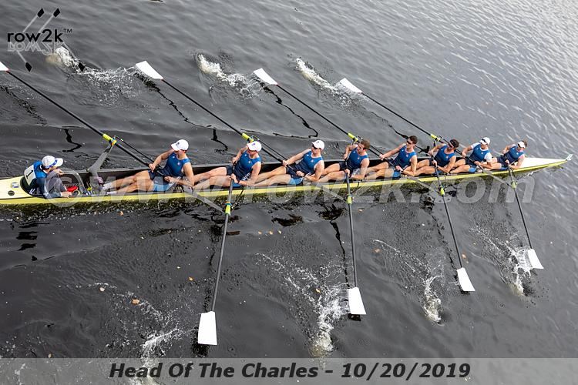
Final thoughts: Think of this like being fit to a new bike. There are professionals who get paid lots of money to fit cyclists to really expensive bikes. Cyclists spend lots of money changing saddles, shoes, peddles, handle bars, and much more. All this is done because it matters to speed, comfort, and health. Rowing should be no different same. The sport is quickly evolving to allow that. Manufacturers are making a point of telling customers how their new designs can fit rowers much better, and be changed much easier.
Some believe rigging mattes a huge amount to boat speed, but most think it is only a small part of the overall equation. Granby Crew is more toward the latter. That said, consider that races can be won or lost by milliseconds. A one-boat-length margin of victory in a2000m eights race is just 1% of the total distance rowed. Even if rigging is only 1% of total boat speed, it matters.
Some say that even if rigging matters, don’t teach the students about it. There’s just too much to understand, and athletes already have enough to worry about while practicing or racing. Priority three at Granby Crew is teaching and learning. Teaching means we want you to understand, and we trust you to deal appropriately with the information provided. Learning means that you understand (or get clarification), and because you understand you will remember what to do and you will do it.

