Hip hinge
To prepare for the next lifting session, grab a broom handle or other straight bar of sufficient length and complete some hip-hinge drills (see attached picture). As the amount we're lifting goes way up in the weight room, you are risking injury during squat and deadlift if you don't know how to properly hip-hinge and maintain a neutral spine. Way too many of us round the lower back, instead of rotating at the hips. If you want to maximize the amount you can lift, you have to learn this proper form.
Start by standing up straight. Then hold the broom handle as shown so it is in contact with the back of your head, your thoracic spine, and your tailbone. Note the position and grip of the hands on the bar. The top hand (outside of fingers) is in contact with your cervical spine. The bottom hand (back of palm) is in contact with your lumbar spine. There may be a few adjustments to make depending on your spine shape. The key is to start standing up straight with squeezed glutes, abs tight, chest out, and shoulders down. The spine, bar, and hands have to be properly set or the drill won't work.
Then hinge over at the hips by pushing your butt back as you bend at the crease between the legs and the hips. The knees bend, but only to maintain balance over your mid-foot. The point is to rotate at the joint where the femur inserts to the pelvis. The shape of the spine does not change. The contact points on the bar and on your hands remain the same. As soon as there is any change in spine shape, stop bending over, reset, and do it again. The goal is to bend all the way over feeling no change in contact with the bar. Any feel of contact change means start over and fix that mistake on the next rep.
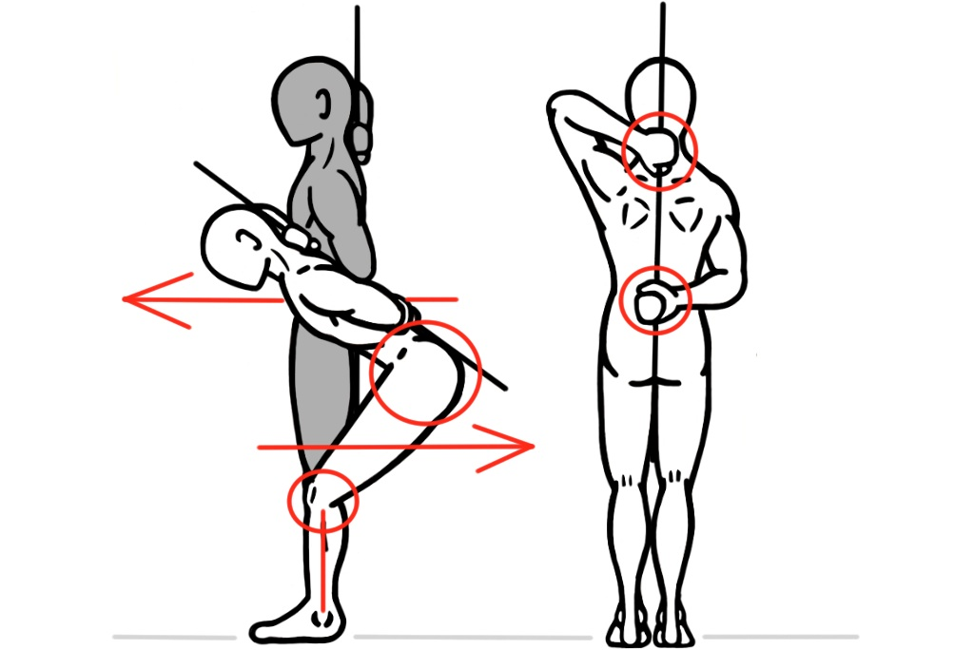
The most common point to be lost is on the tailbone. This is because we’re all used to sitting with rounded back. If this is you, try focusing on the belly button rotating forward and down (counter-clockwise in the picture) while the tailbone rotates backward and up (also counter-clockwise). Make the hamstrings stretch as soon as possible in the movement. That means the lumbar spine is staying neutral. Maximize that stretch all the way through. Losing lumbar spine neutrality almost always starts with tight hamstrings.
Ultimately you need to bend over far enough to reach down to the middle of your shins (where the bar is for deadlift). Every few times, swap which arm is up and which arm is down (prevents imbalances). Once you've got it prefect with the broom handle, do it perfectly without the broom (preferably while looking in a mirror). Try holding the static position to verify the right muscles are working. You’re doing it right if the hamstrings and abs get tired. You’re doing it very wrong if your lower back starts to ache.
Do it slow sometimes, and fast others. Deadlifts are up strong and down controlled; try that. Feel the hamstrings pull your torso up over your legs. Feel your glutes drive your hips forward. Training on spine neutrality for deadlift will help you do it on squats, bent-over-rows, jumpies, erging, and much more. Once the deadlift practice is done, do some deep squats with the broom handle to test your spine neutrality (preferably while looking in a mirror).

